Ruh.ai V1 Tenant Overlay Kit
Construction Project Operations - Procore + SharePoint + Teams
Deployment-ready overlay for one contractor, one trust boundary, and repeatable project operations workflows

VERSION  0.1.0 | PACK REF  construction-project-operations@1.0.0 | PRIMARY USE  Pilot + first production overlay | DATE  2026-03-08

Executive snapshot
This overlay kit binds the reusable Construction Project Operations Pack to a contractor stack where Procore is the official project record, SharePoint stores durable documents and generated outputs, and Microsoft Teams is the collaboration and approval surface.
The overlay is designed for general contractors and larger specialty contractors that already operate one project at a time through structured PMIS and document systems but still spend too much staff time on routing, document assembly, draft preparation, follow-up, and weekly reporting.
The recommended first activation slice is intake and routing, RFI lifecycle, submittal lifecycle, and meeting-action sync.
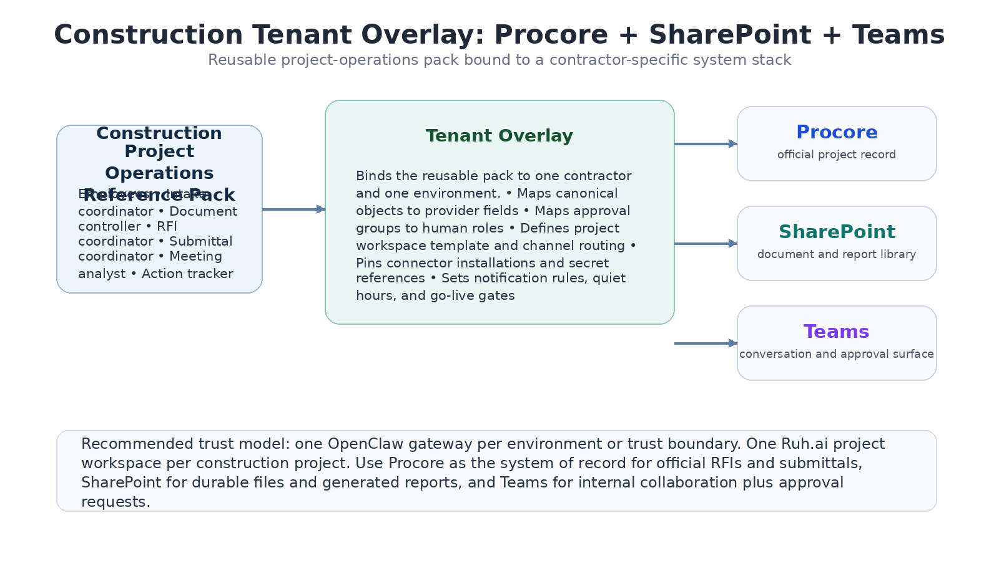
Figure 1. The overlay binds one reusable pack to one contractor stack and one trust boundary.

1. Purpose, scope, and design choices
This document is the deployment companion to the Construction Project Operations reference pack. It translates the horizontal pack into a concrete tenant-specific configuration pattern for contractors running Procore, SharePoint, and Teams. The kit defines how canonical construction objects are mapped, which employees are enabled, where official records live, what approval rules apply, and what must be true before the overlay can be promoted from pilot to production.
- Use Procore as the official record for RFIs, submittals, and project metadata that already live in the PMIS.
- Use SharePoint as the durable repository for generated meeting packs, status reports, exported bundles, and supporting project files that should remain easily shareable inside Microsoft 365.
- Use Teams as the internal collaboration surface for notifications, approvals, and daily operator interaction with digital employees.
- Keep one Ruh.ai project workspace per construction project so context, citations, and approvals stay cleanly scoped.
Out of scope in this overlay
Autonomous safety decisions, schedule resequencing, financial commitments, procurement commitments, or any action that changes project obligations without human approval.
Replacing Procore, SharePoint, or Teams. The overlay sits above them and writes back into them in a controlled way.

2. Stack assumptions and tenant prerequisites
The overlay only works cleanly when the contractor already has one digital backbone per project. The goal is not to digitize a paper-first organization from scratch; the goal is to remove administrative drag from a digitally active team.
Area | Minimum requirement | Why it matters
Procore | API-enabled company account, project list, RFIs and submittals already managed in Procore | The overlay depends on stable IDs and official write-back targets.
SharePoint | Project libraries with controlled access and consistent folder patterns | Generated packs and citation bundles need a durable document home.
Teams | Project or department channels plus an approval channel for operations leads | Human-in-the-loop approvals and digest delivery need a reliable surface.
Identity | Named users and groups for project engineers, document control, PMs, and escalations | Policies must resolve to real approvers instead of free-text names.
Project coding | Consistent project code / project name convention across systems | Cross-system routing is much easier when one project key exists everywhere.

3. Overlay topology and trust-boundary model
The overlay is applied at the tenant environment level, then parameterized per project. The recommended topology is one OpenClaw gateway for each trust boundary such as dev, staging, and production, with one Ruh.ai project workspace inside that boundary for each active construction project. This matches OpenClaw's documented one-trust-boundary-per-gateway model and keeps project memory separated from other projects.
- Tenant level: contractor-wide defaults, connector installations, approval role mappings, and notification defaults.
- Environment level: dev, staging, and production runtime settings, secret references, and gateway profile.
- Project level: Procore project ID, SharePoint library path, Teams channel bindings, project contacts, and workflow activation state.
- Workspace level: citation cache, generated drafts, temporary bundles, and run telemetry for one project only.
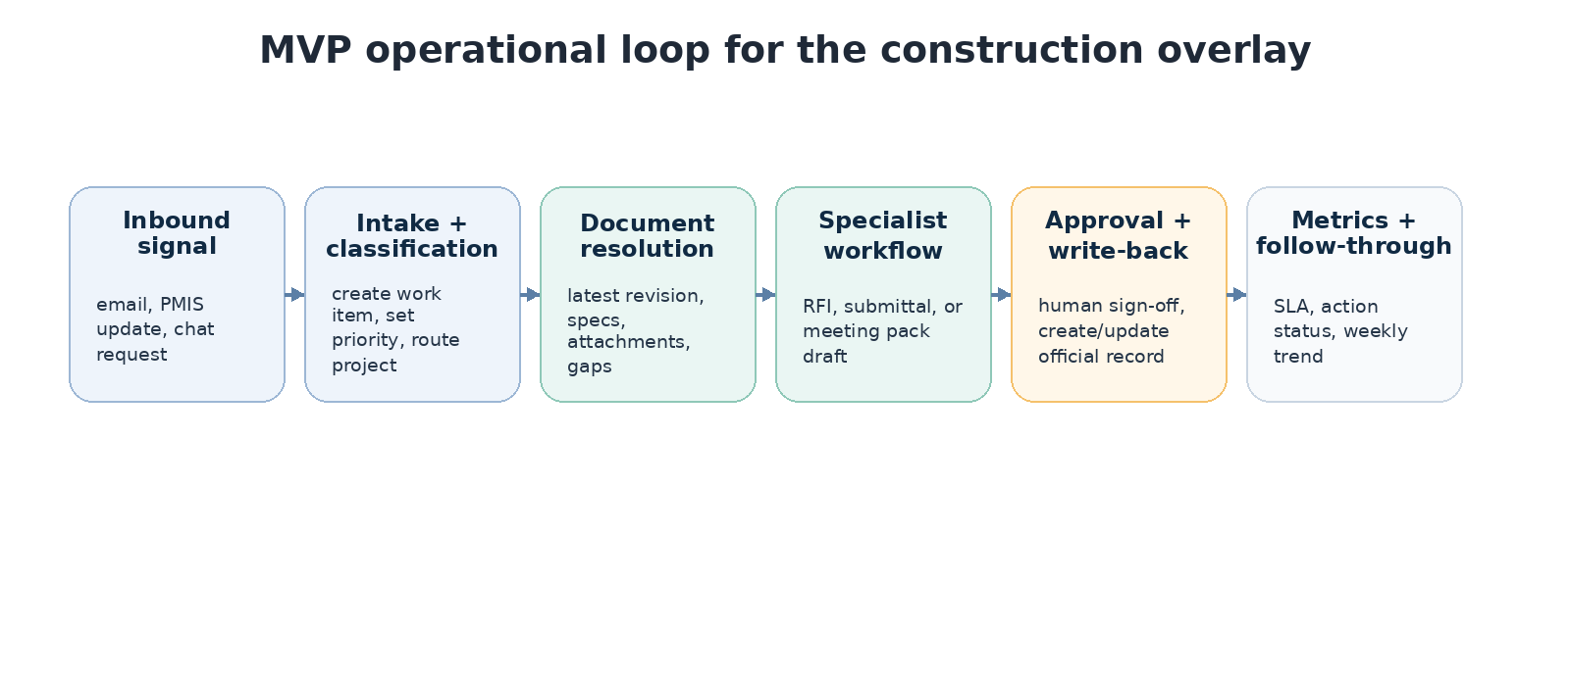
Figure 2. MVP workflow loop recommended for the first construction overlay rollout.

4. Canonical object mapping
The overlay maps provider-specific fields to the pack's canonical construction vocabulary. Workflow logic should consume canonical objects; only the connector layer should know vendor field names.
Canonical object | Primary source | Secondary source | Notes
Project | Procore project | Teams channel prefix + SharePoint library | Project code should be the stable cross-system key.
DocumentRef | SharePoint file or Procore attachment | SharePoint controlled file path | Document controller resolves the latest approved version.
RFI | Procore RFI record | SharePoint citation bundle copy | Official state stays in Procore.
Submittal | Procore submittal package | SharePoint supporting docs | Official review state stays in Procore.
MeetingPacket | SharePoint generated file | Teams delivery message | Teams distributes; SharePoint stores.
ActionItem | Ruh.ai task artifact | Teams follow-up thread | Action tracker owns due-date reminders and status rollups.
ApprovalGroup | Azure AD / M365 group | Ruh.ai policy reference | No free-text approver resolution in production.

5. Employee activation and permission envelope
The tenant overlay should never enable a digital employee without an explicit permission envelope. The matrix below is the minimum v1 posture.
Employee | Primary actions | Auto allowed | Approval required
Project intake coordinator | Classify inbound requests, open work items, route to project | Create internal tasks and Teams summaries | None by default
Document controller | Resolve latest documents and build citation bundles | Read docs, assemble context bundle | Publishing externally shared bundles
RFI coordinator | Draft RFIs and propose routing | Internal draft generation | Create or update official Procore RFI
Submittal coordinator | Prepare review package and status summary | Internal package draft, due-date watchlist | Create/update official Procore submittal record
Meeting & reporting analyst | Generate OAC pack, weekly summary, trend view | Generate SharePoint files and internal Teams posts | External distribution beyond internal channel
Action & risk tracker | Reminder nudges, overdue watch, risk status rollup | Internal reminders and status digests | Escalation outside mapped Teams channels

6. Workflow activation plan
The overlay should not activate every pack workflow on day one. Start with high-frequency, low-ambiguity flows that have a clean system of record and measurable cycle-time impact.
Workflow | Trigger | System of record | Primary metric
Intake & routing | New email, Teams request, or monitored PMIS event | Ruh.ai work item + Teams notification | Time from inbound signal to assigned task
RFI lifecycle | Question or missing-info request tied to a project | Procore RFI | Draft-to-submission turnaround and citation accuracy
Submittal lifecycle | Incoming submittal package or due-date watch condition | Procore submittal record | Cycle time and overdue reduction
Meeting-action sync | Scheduled weekly/OAC cadence or manual request | SharePoint file + Ruh.ai action items | Hours saved per week and overdue action reduction
Recommended pilot order
Week 1-2: turn on intake routing and document resolution only, with no external write-back.
Week 3-4: add supervised RFI drafting and PM approval before Procore create/update.
Week 5-6: add submittal package preparation and due-date watchlists.
Week 7-8: add recurring meeting pack generation and action tracking digests.

7. Connector profile and secrets inventory
Connector | Required access | Secret reference pattern | Health check
Procore | Read projects, RFIs, submittals; create/update permitted records | secretref://connectors/procore/* | Project list fetch + create draft dry run
SharePoint | Read controlled docs; write generated outputs to approved libraries | secretref://connectors/sharepoint/* | Library list + test write to Ruh Output
Teams | Post in mapped channels; receive bot mentions or app events | secretref://connectors/teams/* | Post test message + approval card round-trip
Ruh runtime | Bundle apply, task execution, telemetry upload | secretref://runtime/* | Adapter heartbeat + bundle checksum verification
All secrets are referenced indirectly through secret refs. No tenant overlay checked into source control should ever contain raw tokens, client secrets, or user passwords.

8. Policy and approval overlay
This overlay uses a three-tier action model to keep automation valuable without putting official project records at risk.
Risk tier | Examples | Default policy | Approver
Low | Internal summaries, task creation, reminder nudges | Auto allowed | None
Medium | Creating or updating RFI/submittal drafts in Procore | Approval required | Mapped PM or document-control role
High | Owner/designer messages, obligation-changing records, external distribution | Human only or approval required with named role | PM + escalation role if required
- No outbound message to owner, designer, or subcontractor should auto-send from the overlay in v1.
- Any missing citation bundle, stale revision warning, or document conflict automatically downgrades the action to manual review.
- Override decisions must record the approving user, timestamp, and reason code.

9. Notification, routing, and record ownership rules
Artifact / event | Primary destination | Owner of record
Task assignment | Teams project-ops channel | Ruh.ai work item/task record
Approval request | Teams approvals channel or mapped PM chat | Ruh.ai approval record
Official RFI/submittal update | Procore + Teams confirmation | Procore
Meeting packet | SharePoint file + Teams message link | SharePoint file
Daily digest | Teams project-controls channel | Ruh.ai generated summary artifact
Teams is the interaction surface, not the system of record. The overlay should send links back to Procore or SharePoint rather than treating chat history as the official audit trail.

10. Pilot acceptance gates and success metrics
Gate | Target before go-live
Connector auth | All three external connectors pass health check and least-privilege review.
Project routing | At least 95% of inbound signals route to the correct project in eval replay.
Citation quality | At least 90% of pilot drafts include valid latest-revision citations.
Approval compliance | 100% of medium/high-risk actions create an approval record or remain blocked.
Cycle-time impact | Pilot shows measurable reduction in RFI/submittal administrative turnaround.
Recommended pilot KPIs
RFI draft turnaround time
Submittal package prep time
Overdue action item count
Hours saved per project engineer per week
Percent of write-backs completed only after correct approval path

11. Example overlay excerpt
The full starter file is provided separately with this kit. The excerpt below shows the intended structure and the major fields solution engineers are expected to fill.
kind: tenantOverlay
apiVersion: ruh.ai/v1alpha1
metadata:
overlayId: construction.procore-sharepoint-teams
packRef: construction-project-operations@1.0.0
displayName: Procore + SharePoint + Teams overlay
owner: solutions-engineering
environmentClass: production
version: 0.1.0
trustBoundary:
key: contractor-prod-east
runtimeProfile: prod
gateway:
mode: dedicated
workspaceStrategy: project-per-workspace
sandbox:
mode: non-main
scope: agent
projects:
template:
workspaceIdPattern: constr-{project_code}
channelBindings:
internalTeam: teams:{project_code}-ops
approvals: teams:{project_code}-approvals
connectors:
procore:
enabled: true
installationRef: secretref://connectors/procore/app-prod
companyId: ${PROCORE_COMPANY_ID}
projectFieldMap:
projectId: procore.project.id
rfiId: procore.rfi.id
submittalId: procore.submittal.id
sharepoint:
enabled: true
siteRef: ${SP_SITE_URL}
libraryMap:
controlledDocs: /Shared Documents/Controlled Project Files
generatedReports: /Shared Documents/Ruh Output
teams:
enabled: true
botRef: secretref://connectors/teams/bot-prod
quietHours: "20:00-06:00 America/Chicago"
roleMappings:
approvals:
rfiOwner: group://project-engineers

12. Day-2 operations and change control
- Any change to provider mappings, approval groups, or write-back permissions should go through the same promotion flow as a code change: dev -> staging -> production.
- Project-template changes should be versioned. Never mutate active production overlays in place without a rollback snapshot.
- Connector credential rotation should be tested in staging before production cutover whenever possible.
- Escaped production mistakes should become new eval cases before the next overlay release.

Appendix A. Source assumptions
This overlay kit assumes OpenClaw is used as a trust-bounded runtime plane with isolated agents, workspaces, routing bindings, AgentSkills-compatible skill folders, configurable hooks/cron automation, and optional sandboxing. The overlay design also assumes the documented security posture of one trusted operator boundary per gateway, which is why production deployments should separate customers and environments at the gateway layer.
- [R1] Agents - OpenClaw (isolated agents, workspaces, routing).
- [R2] Skills - OpenClaw (AgentSkills-compatible skill folders and precedence).
- [R3] Hooks - OpenClaw (event-driven automations discovered from directories).
- [R4] Cron Jobs - OpenClaw (persistent gateway scheduler).
- [R5] Security - OpenClaw (one trusted operator boundary per gateway).
- [R6] Agent Workspace - OpenClaw (workspace as default cwd; sandbox recommended for isolation).

